# Assignment 9

Name:Harish Kamuju

UTA ID: 1001120930

1. Implemented using google app engine and python with D3.js
2. Uploaded Consumer_complaints.csv file from the gov data to the local cloud storage.
3. As 1st part implemented scattering based on Product type and number of complaints for that product.
4. 2nd part was implemented using bar graphs for data set as state and state wise number of complaints.
5. 3rd part was implemented on Product type and its complaints as a bar graph
6. 4th part was kmeans clustering of state ,year and its complaints, used inverse term frequency and vectorizer concepts for the program.

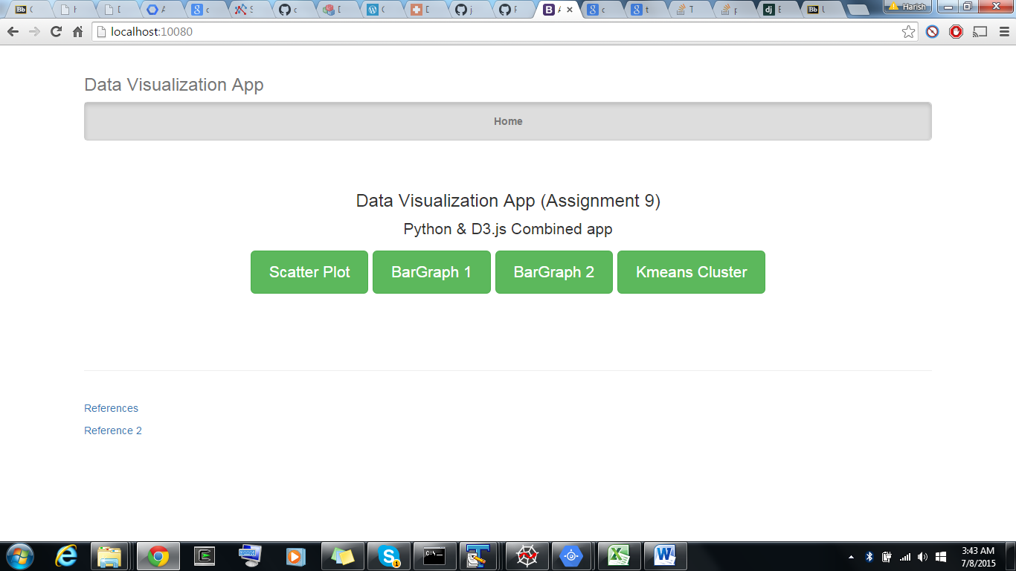

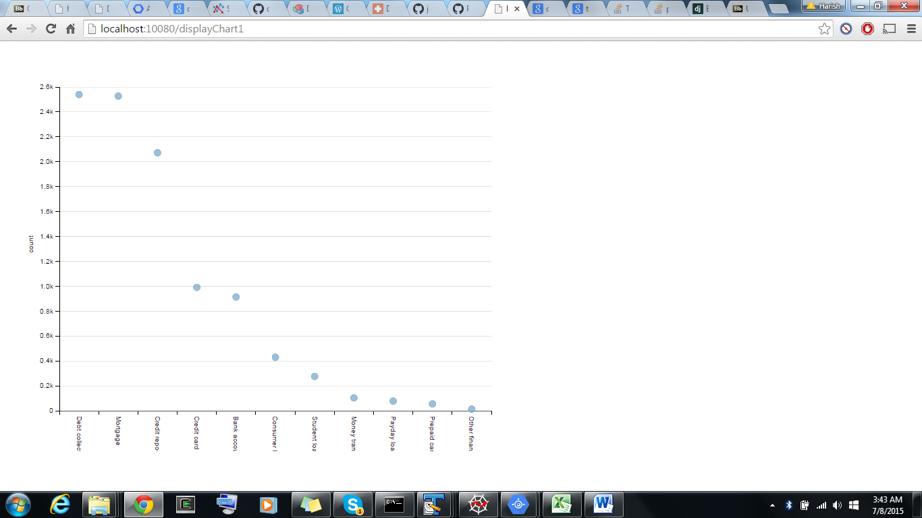

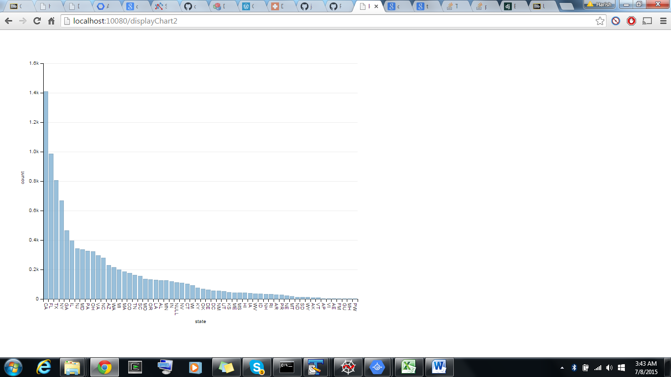

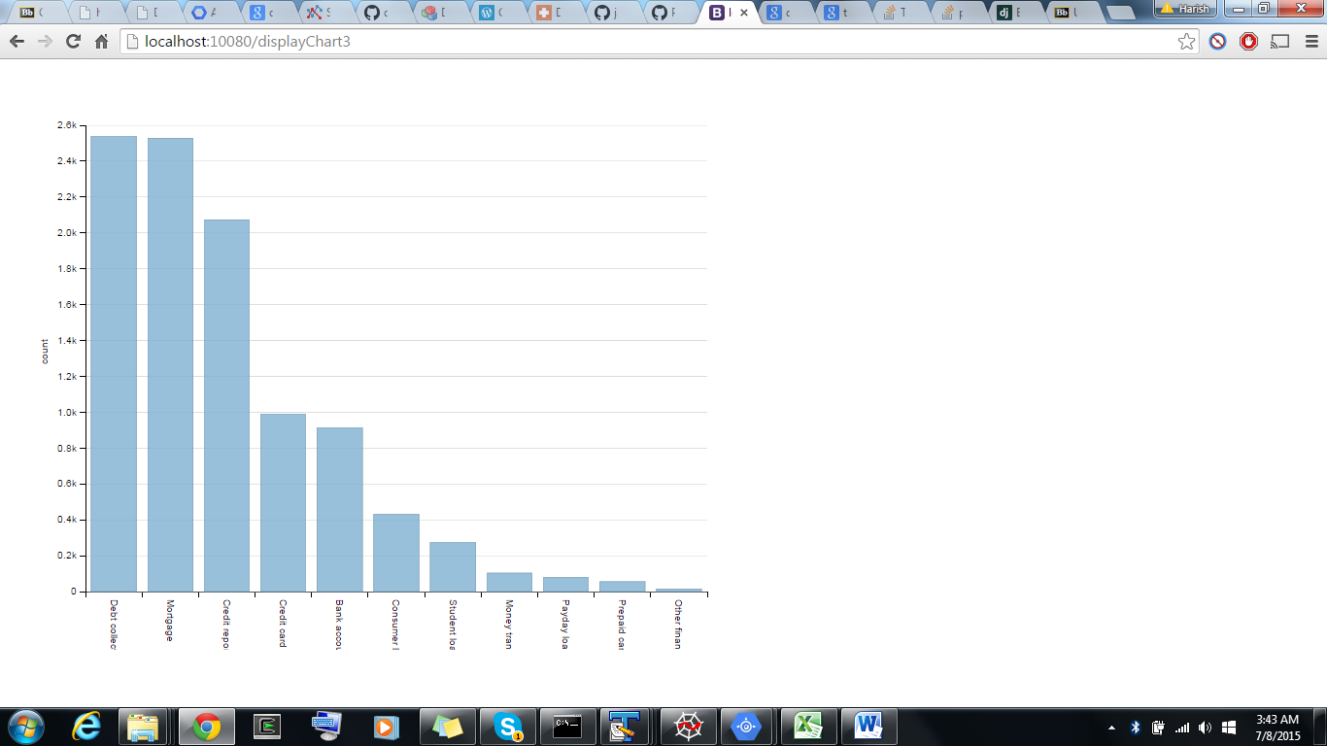

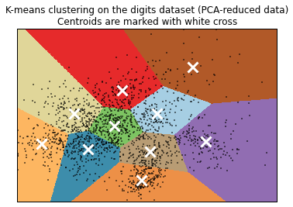

References:

<http://pythond3jsmashup.appspot.com/>

<http://code.tutsplus.com/tutorials/data-visualization-app-using-gae-python-d3js-and-google-bigquery--cms-22175>

<http://dimplejs.org/examples_viewer.html?id=scatter_standard>